FTF FY 2023 Performance Scorecard Sri Lanka

This Feed the Future (FTF) Performance Scorecard assesses the Sri Lanka progress toward FY 2030 Performance Targets.

# Performance Overview



The FY 2023 **On track** value is determined by drawing a line from the baseline (FY 2022) to the FY 2030 Target. For FY 2023, Performance Targets are considered **On track** if they have reported at least 90% of that value.

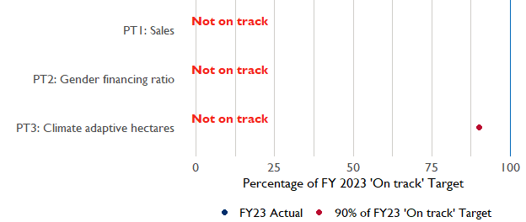

**Note:** *For Performance Target 2 (Gender financing ratio), the target is to increase financing to females for those OUs that are already achieving parity ($1).*

*For Performance Target 4 (PSI), all targets are relative to the last three years’ reporting. In future years, the interim targets may increase.*

*For Performance Target 5 (MDD-W), all FY23 actual values are also the baseline, and may have been collected in a prior year. See the detail page for more information.*

*See detailed* [*methodology document*](https://docs.google.com/document/d/13n-43ppFiGKauscQ7HaAiQDCM4DssGEgRdq2fMyTDn0/edit) *here. If you have questions, please email the FTF Data and Analytics team at* [refs.adl.da@usaid.gov](mailto:refs.adl.da@usaid.gov).

### Performance Target (PT) Details

This section shows PT scores for each applicable PT for Sri Lanka.

## Performance Target 1: Value of annual sales of producers and firms receiving USG assistance



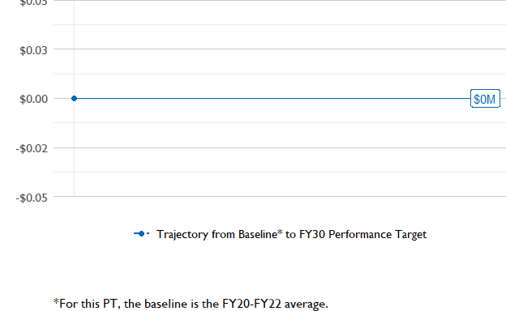

In FY 2023, USAID Sri Lanka had 0 activities that aligned the ‘Value of annual sales from producers and firms receiving USG assistance’ (EG.3.2-26), and 0 contributed to the sales total of NA.

###### Performance Target 2: Value of financing accessed by female FTF participants per $1 of financing accessed by male FTF participants





In FY 2023, USAID Sri Lanka had 0 IMs/Activities that reported all four sex disaggregates needed to contribute to PT2. The total value of financing among all activities, regardless of disaggregates, was NA (EG.3.2-27 total), with NA that was disaggregated by females and males, and an additional 0 to ‘mixed’ firms that have both males and females, and NA that was not sex disaggregated.

###### Performance Target 3: Number of cultivated hectares under climate adaptation/climate risk management practices and technologies with USG assistance



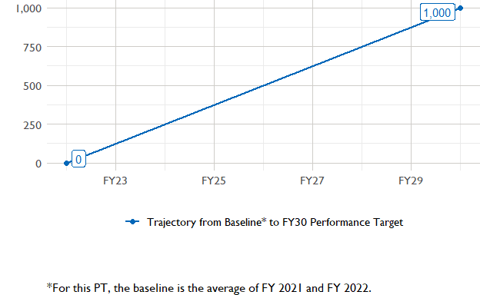

In FY 2023, Sri Lanka had 0 activities that aligned the indicator for hectares under improved management practices (EG.3.2-25). Of those activities, 0 reported on the ’’ disaggregate and contributed to the OU total for this PT.

###### Performance Target 4: Value of private sector investment leveraged by the USG to support food security and nutrition





USAID Sri Lanka did not report on EG.3.1-15 in FY 2023.

###### Performance Target 5: Percent of women consuming a diet of minimum diversity (MDD-W)



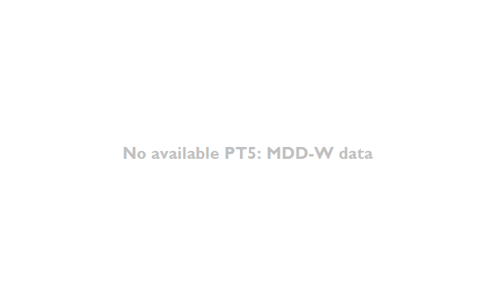

PT5 is not available for USAID Sri Lanka.

### National Context

National level data was collected from the [World Bank’s Open Data portal](https://data.worldbank.org/) that measures key indicators at the national level.

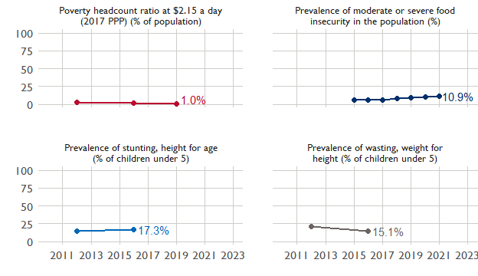

## Agricultural Transformation Index Score

The IFPRI Agricultural Transformation Index (ATI) Score is a high level indicator of the status of agricultural market systems in each country.

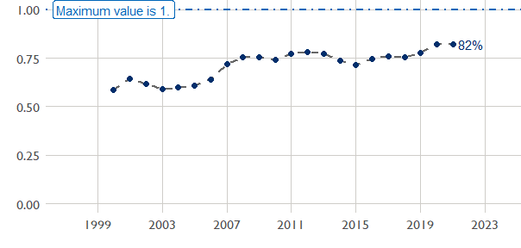

## Budget Trend

At the Operating Unit level, the Performance Targets are based in part on the FY 2024 budget request. The budget chart below includes EG.3 money only.

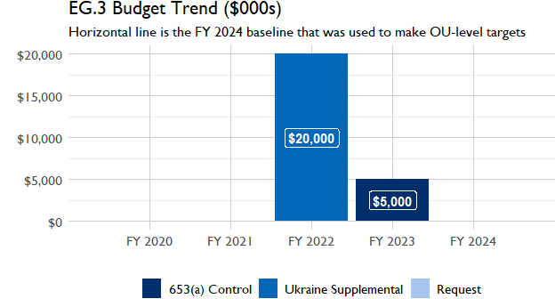

## Active Portfolio

The following activities are considered “active” based on their reporting in FY 2023 and expected FY 2024 reporting. The Analytics, Data and Learning Division defines an “active” activity as one that reported targets, actuals, or deviation narratives for the current year (FY 2023), or the next out year targets (i.e. FY 2024).

## Top Activities (Award Disbursements and Results)

This section highlights the 0 activities (out of the total 0 in the Sri Lanka portfolio) that have the highest level of FY 2023 annual disbursements and highest reported values for the relevant indicators. The first table below shows activities with the highest total transaction amounts. The columns to the right indicate if these activities are reporting on relevant PT indicators.

| Award Number | Activity Code | Activity Name | FY23 Disbursements | PT1 | PT2 | PT3 | PT4 |
| --- | --- | --- | --- | --- | --- | --- | --- |

The next table (below) shows the activities that reported the highest values for the relevant PT indicators. The total disbursements are included, if available.

| Award Number | Activity Code | Activity Name | Total Disbursements | Sales | Hectares | PSI |
| --- | --- | --- | --- | --- | --- | --- |

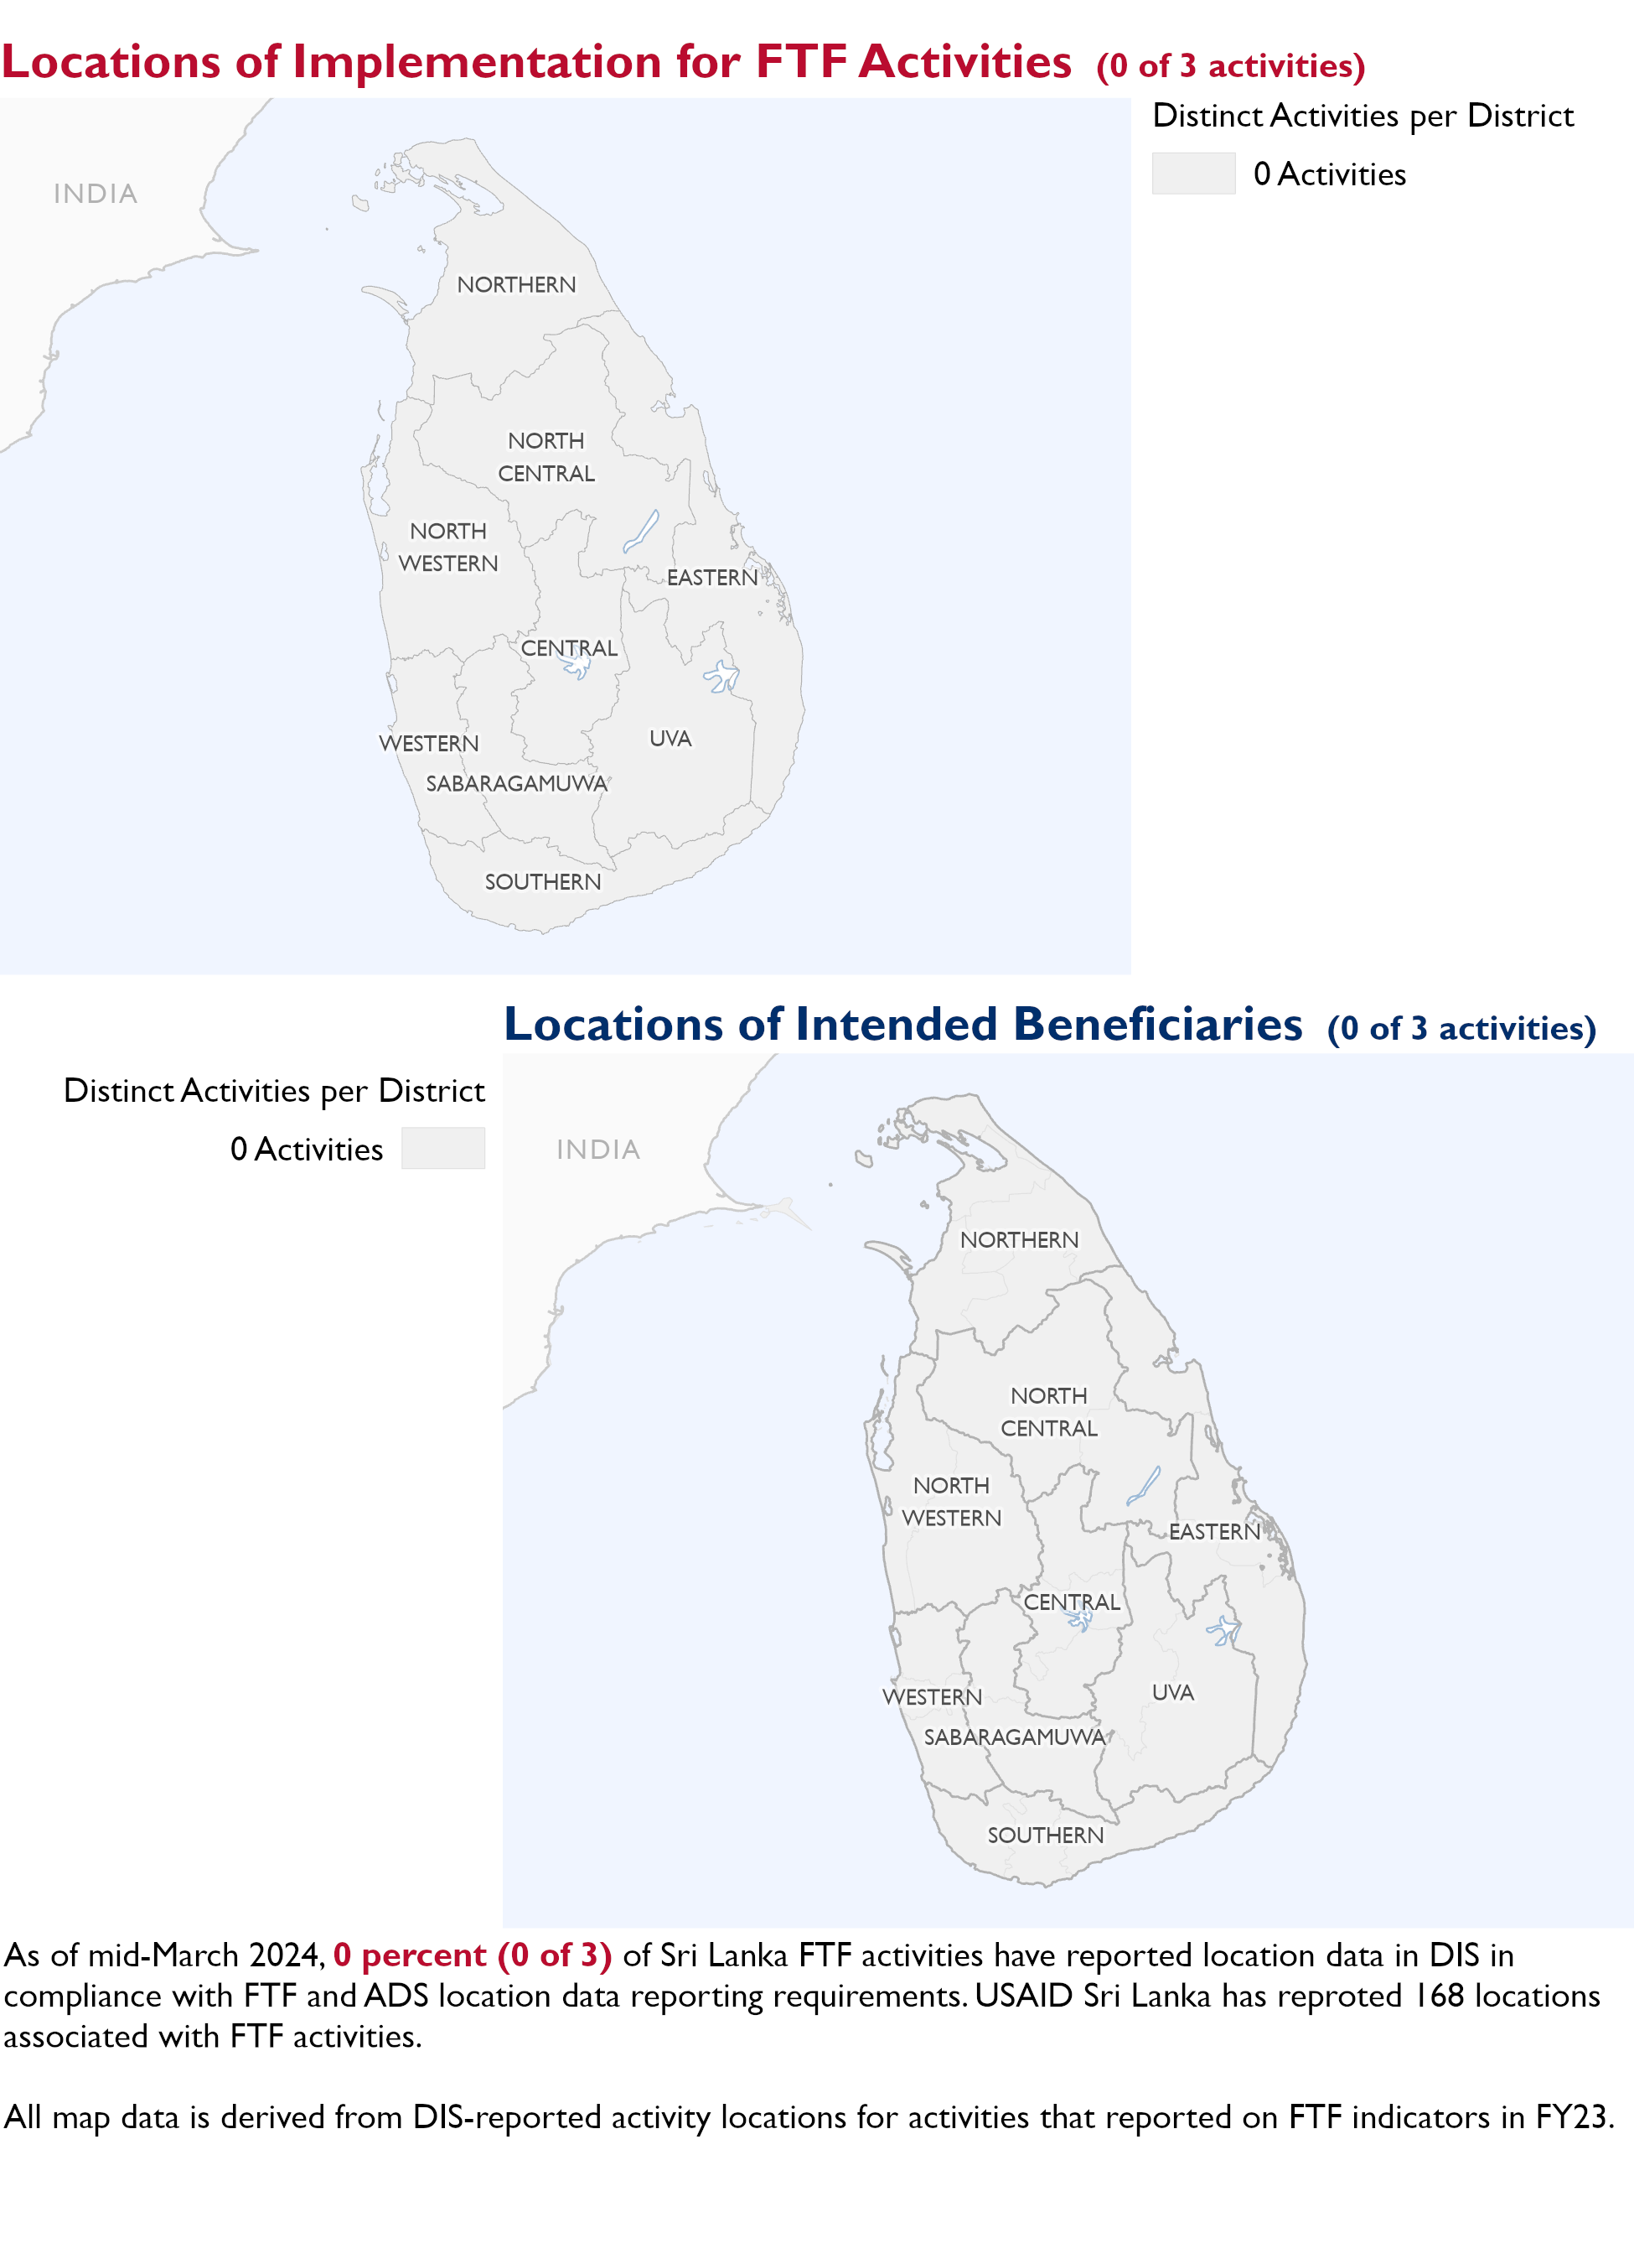

### Appendix 1: Response to “Not on track” Performance Targets

This section provides space for Sri Lanka to provide an explanation of why the following PTs are not on track and how you could adjust to be on track in the coming year(s). To help in your response(s), the relevant section of the FTF/GFS Key Issue Narrative (KIN) is provided, as it *may be* useful in drafting a responses. Note that the KIN is addressing the sum of the out year targets (FY 2023) set by the Sri Lanka activities that are reporting on each PT. The FY 2023 out year targets were set prior to the establishment of the FY 2030 Performance Targets, so the below explanations from the KIN may not apply to the Performance Target deviation.

* In Section 4 of the FTF KIN, your OU discusses FY24 and FY25 targets, while these Scorecards are addressing progress against a trajectory from historical reporting to your OU’s FY30 target. Also, the FY 2023 out year targets were set prior to the establishment of the FY 2030 Performance Targets. Therefore, the below explanations from the KIN may not apply to these FY30 Performance Target deviations.
* These responses will be used to compile a Congressional report, the GFSS Implementation Report, to discuss progress against the FTF FY 2030 Performance Targets, as mandated by the GAO.
* Only PTs that are ‘Not on Track’ require review and explanation from the OU.

Include in the response:

1. An explanation of why this target is not on track. Explanations may include that the OU/Mission was not aware of the target prior to planning activities.
2. Planned actions for ‘not on track’ targets. Planned actions may include the launch of new activities, building awareness, holding portfolio reviews, or other suggestions.

## Performance Target 3: Hectares under climate adaptive and risk management practices [Not on Track]

*Excerpt from FY23 KIN Section 4 to consider:* /A

#### Enter Sri Lanka response below: